The Deconstruction of “Female Madness” in Female Surrealist Art

Divya Parikh

11 May 2020

Professor Sidlauskas

Art History Capstone Paper

**Introduction**

Based on theories of psychoanalysis, surrealist art is known for representing the unconscious mind and imagination. In doing so, however, male surrealists often cast a submissive image of women, looking to the female body as a muse for the projection of male fantasies. Artwork by male surrealists is wrought with images of dismembered, distorted, and “hysteric” female forms, perpetuating the trope of “female insanity” put forth by psychoanalysts and romanticizing mental illness. Although primarily known for its male artists, the surrealist movement also gave rise to a new wave of female artists who sought to address the improper representation of women in art. Among this group, Leonora Carrington, Kay Sage, and Remedios Varo are particularly significant for their use of portraiture as a means of deconstructing the sexualized image of the “female madwoman” and depicting complex women subjects.

**The Exploitation of the Female Body in Male Surrealist Art**

Marking the start of the literary and artistic movement known as Surrealism, André Breton’s *Manifeste du Surréalisme* outlines the value in exploring the unconscious mind and imagination in surrealist work. Coining the term “psychic automatism,” Breton describes surrealism as a newfound focus on the undisrupted human psyche and the liberation of the mind from moral predispositions.[1] However, pulling heavily from Sigmund Freud’s theory of the unconscious, Breton’s ideologies create a predominantly masculine definition of the movement, writing women off as disturbances to the liberated male mind.[2] Breton posits the role of both women and madness towards the study of the male psyche. Looking to madness as a rejection of societal rules and expectations, surrealists aim to “[pry] loose the secrets of the insane” and achieve a similar level of imaginative freedom.[3] In a similar fashion, the female body is a symbol of the heterosexual perversion which is restricted to the male unconscious mind.[4]

The image of female madness can be in part attributed to a long history of gendered medical research which labels women as predisposed to certain mental disorders. French neurologist Jean-Martin Charcot’s work with female “hysteria” is worth noting for its impact on Breton’s literature as well as the surrealist movement overall. Opening a clinic at the La Salpêtrière Hospital in Paris, Charcot investigated hysteria in young women, deeming the condition a primarily physiological disorder characterized by convulsive episodes and agitated fits.[5] His work was not only exploitative, but also extremely theatrical; referring to his clinic as a “living museum of pathology,” Charcot approved the photography of his patients and often used them for medical demonstrations, blurring the line between medicine and art.[6] A common theme throughout the photographs of Charcot’s patients, which are disseminated in the *Iconographie Photographique de la Salpêtrière*, is the image of a convulsive fit in which his patients arch their backs in a pose that would later be coined the “arch of hysteria” (see fig. 1).[7] Breton comments on the “young hysterical females” studied by Charcot, drawing the connection between beauty and convulsion and arguing that hysteric women represented a “supreme vehicle of expression.”[8]

As a result, the image of female insanity and passivity pervades the canon of male surrealist art, exploited as a source of reaching the male unconscious. Dali’s *The Phenomenon of Ecstasy* (fig. 2), a photo-collage of female hysterics, demonstrates the influence of Breton and Charcot’s work on the surrealist movement. Combining images of mentally ill women, many of which came from Charcot’s photographs, and masculine features, such as the ears, Dali illustrates the relation between hysteria and ecstasy and reinforces stereotypical gender norms. In their attempt to portray the unhinged dreamscape, male surrealists looked to women as reflections of their own masculine fantasies.[9] An example of this is Hélène Vanel’s *Unconsummated Act* (fig. 3) at the 1938 *Exposition Internationale du Surrealisme*: a performance piece orchestrated by male artists in which the dancer reenacted a hysterical fit in a sexualized manner.[10] Vanel, dressed in revealing clothing, thrashed her body against a hospital bed, arching her back in the same pose as that of Charcot’s convulsive patients. Her performance romanticizes the idea of female hysteria, literally acting out male fantasies of women as submissive and sexual beings.

**Women of Surrealism and the Role of Portraiture**

Female surrealists looked to art as an outlet for self expression, attempting to correct the misogynistic image of women inherent in the surrealist movement. While male surrealists most commonly sought to portray the unconscious mind, their artwork rarely consisted of personal memories or experiences.[11] For women, surrealism was a way in which to reclaim and reflect on their sense of identity, often expanding on aspects of their culture or past experiences. Their artwork challenged stereotypical notions of gender and identity, portraying women as animals or androgynous beings. In line with this self exploration, female surrealist art heavily consisted of portraiture in varying mediums, allowing women to regain agency in their representation and reject the Freudian image of the “madwoman.” This paper analyzes the deconstruction of female insanity in the portraiture of three female surrealist artists who sought to address issues of mental illness and female agency: Leonora Carrington, Kay Sage, and Remedios Varo.

**Leonora Carrington**

British-born Mexican artist Leonora Carrington is known for her haunting, dreamlike compositions, which galvanized the female surrealist movement. Carrington’s work is unique in its themes of liberation and metamorphosis. Wishing to escape the confines of her aristocratic and highly religious household, Carrington developed a desire for freedom and affinity for rebellion at a young age.[12] Carrington’s earlier paintings reflect her disdain for the untaxing reality of privileged life, which restricts women to a domestic and submissive role. She also speaks to her experience with mental illness after suffering a mental collapse in 1940 and being admitted to a Spanish mental asylum, offering an unromanticized perspective.[13] Carrington’s *Down Under* provides an autobiographical account of her treatment at the asylum, where she was helplessly subjected to drug-induced shock treatments.[14] Deconstructing the notion of “convulsive beauty” put forth by Breton and male surrealists, Carrington describes her appearance after the psychiatric abuse as “pitiably hideous,” arguing the extremely difficult and personal experience that she underwent: “not Breton nor anyone has ever seen the inside of a Spanish madhouse.”[15] Carrington speaks to this experience in her work, which uses portraiture to project her battle with mental illness.

**Liberation and Animal Symbolism in Carrington’s Work**

Employing images of magic and mythical creatures, Carrington channels the Celtic lores told by her mother as an allusion to her escape from both a restrictive childhood as well as feminine oppression.[16] Her most famous piece, *Self-Portrait (Inn of the Dawn Horse)* (fig. 4), demonstrates her penchant for animal forms as a representation for wildness and freedom. The self-portrait features an image of Carrington seated in an elegant blue chair in an empty room resembling that of her childhood. Mirroring her is the image of a pregnant hyena, whose dark and messy mane matches the texture of her own hair. The motif of a white horse is important to Carrington’s work, appearing twice in this painting: the first can be seen prancing in the wilderness and the second in the form of a rocking chair pinned to the back wall. The rocking horse—a reference to a childhood toy with which she developed an imaginary friendship—is a symbol of her lonely upbringing.[17] In contrast, the Queen of Horses in Celtic legends represents an “image of death and rebirth.”[18] Juxtaposing the rocking horse with the free horse, Carrington creates a comparison between the confinement she felt during childhood and the release of escape for which she longed. However, rather than interact with either of the white horses, Carrington’s figure instead points to the hyena, whose black fur and piercing blue eyes exude a sense of feral wildness. On the floor, her shadow connects with that of the hyena’s, dissolving the human-animal boundary and attributing her inability to adhere to her family’s expectations due to an untamed nature.[19] Carrington rejects the throes of upper class society resemblant in the regal chair and curtains and seeks companionship with the rebellion and grotesqueness present in the hyena. Carrington displays her metamorphosis in this self-portrait, representing herself in each of the animals depicted as well as in the image of herself. Rebuking the idea of the woman’s role in unlocking the male unconscious, Carrington suggests a powerful fusion between nature and dreams that gives agency to the female creative mind.

Carrington’s *Self-Portrait with Orthopedic Brace* (fig. 5), created after her stay at the Spanish mental institution, draws a stark contrast with her earlier self portrait. The body of work belonging to the second half of her life comments on the problematic treatment of individuals with mental disorders from a female perspective. Set in a haunting, desolate landscape, the painting depicts a cloaked figure, bridging the gap between animate and inanimate. The figure’s top half appears human, reflected in the outline of its shoulders and brown hat placed on its head. However, Carrington replaces the figure’s lower half with a stand, potentially resembling a clothing rack or the IV stands present in hospitals. Rather than metal, the stand appears to be made of bone or wood, mirroring the translucent whiteness of a skeleton yet sprouting small leaves on the sides. A spinal cord, which bears a close resemblance to a mythical creature, floats next to the figure. Carrington includes three figures appearing in a line from background to foreground: a coyote atop a mountain, crouched person, and crow. In Carrington’s account of her psychiatric treatment, she described the seizure-inducing drug given to her, Cardiazol, as “strong enough to fracture vertebrae and stop the heart.”[20] As a result, Carrington depicts her vertebrae as a separate entity from her body to demonstrate the separation between her sense of self and the way in which she was treated during her time as a patient. Carrington illustrates herself as the image of an inanimate object dressed in human clothing, speaking to the way in which mental institutions reduce patients to mere objects. This self portrait alludes to the ever-lasting effects of her time at the asylum on her mental and physical health, depicting Carrington’s personal experience while rejecting the sexualization of her body.

**Kay Sage**

Although born to a wealthy and privileged family, Kay Sage desired to escape the confines of her seemingly perfect household, the life of upper-class American society weighing down on her. Her father, a New York Senator, imposed strict restrictions on Sage and her sister while her mother, a free spirit, was absent both mentally and physically throughout her childhood.[21] After her parents’ divorce, Sage stayed with her mother, taking on the role of a parent as her mother dealt with a debilitating morphine addiction.[22] Physical and mental health was an obsession of Sage’s throughout her life; stemming from observing her mother’s health decline as well as the deaths of her father and sister from tuberculosis, she was always concerned with illness, often vigorously documenting her symptoms.[23] Sage went on to study art in Italy and eventually entered the realm of Surrealism in Paris, marrying one of her contemporaries Yves Tanguy. Although her relationship with Tanguy was toxic—with certain accounts reporting signs of his verbal and physical abuse—the artist shared an attachment to her partner and spiraled into depression following his unexpected death in 1955.[24] Sage ended her life a few years later after having developed cataracts and begun to lose her vision, unable to cope with her deteriorating mental and physical health.[25] Although her work is widely revered, it is often misinterpreted for portraying an image of a “serene subconscious” in comparison to the loud works of her contemporaries. Instead, Sage’s artwork is remarkable in its representations of loss and illness, which stem from the artist’s complicated life.

**Sage’s Focus on Solitude and Architecture**

Dubbed the “Solitary Surrealist,” Sage is well-known for her mysterious architectural renderings, which rarely feature human figures. Sage’s *Small Portrait* (fig. 6), created in 1950, is one of only two portraits the artist created throughout her career, featuring the silhouette of a female face constructed from architectural components. The inanimate plays a large role in the artist’s work, originating from her belief that objects possess the ability to “absorb and retain the emotions generated by people.”[26] As a result, the architectural elements in her work carry a similar emotional value and take on the qualities of people. The piece is particularly intriguing in its rebuke of the stereotypical image of a female beauty, juxtaposing architectural pieces with feminine components; for example, a striking mass of red hair peeks out from the top of the face, in contrast with the rigid mechanical beams and screws. Shrouding part of the figure’s face, a soft fabric intertwines with the machine-like skeleton and speaks to the intimacy of the portrait. Sage juxtaposes various textures in her painting—the softness of the hair, rigidity of the beams, and silkiness of the fabric—to show the multitude of characteristics women possess. A set of beams on the left of the figure's face create a staircase of sorts, although showing no way of actually entering the form. While the viewer is able to see through the face, there is a sense of impenetrability exhibited from the fortress of architecture.[27] Reclaiming a right to her self representation, Sage only exhibits as much of her body as she wants the viewer to see, leaving the rest a mystery. As a result, she quite literally deconstructs the form of a woman as a retort to the conventional norms of feminine beauty.

In a later portrait, titled *Le Passage* (fig. 7), Sage grapples with emotions of loss and solitude following her husband’s death, depicting a human figure for the first time in all her work. A self portrait of the artist’s own grief, the painting features the figure of a young Sage seated atop a collection of cubes as she stares out at a barren landscape. Exhibiting only her bare back to the viewer, Sage creates an image of simultaneous vulnerability and impenetrability: the viewer has access to an intimate moment, yet is unable to process the full range of the subject’s emotions. Although the figure is half nude with her hair seductively pulled over one shoulder, the viewer is restricted from seeing her fully and thus, unable to sexualize and exploit her body. The woman’s spine protrudes against her pale skin, contrasting the “arch of hysteria” pose in Charcot’s images as well as the skeleton of a female face in her previous work (fig. 6).[28] Though the only of Sage’s paintings to include a human form, the piece exudes a sense of loneliness. Characteristic of her work, Sage imbues the inanimate parts of her painting with her own emotions. The sky shifts in color from black to hazy blue, portending a dark cloud of grief settling over Sage as she grapples with the loss of her husband. The aerial perspective of the landscape is characteristic of Sage’s architectural style and can take on a number of forms: the tops of buildings, a rural landscape, a cracked earth.[29] Often set in vast, empty spaces, the world of Sage’s paintings adopts the appearance of an abandoned wasteland—a place where something that used to exist no longer does.[30] The landscape infinitely extends into the distance, reflecting Sage’s uncertainty with what her future will hold. In this way, *Le Passage* speaks to the intimate quality of grief and mental illness which often manifests in feelings of nothingness rather than the hysterical fits Charcot and Breton suggested. Sage’s female figures are multidimensional in their representation of self exploration, acting as individual entities of thought and emotion rather than a reflection of the male subconscious.

**Remedios Varo**

Spanish-born artist Remedios Varo began her career in art at a young age at the behest of her parents. Her father, a hydraulic engineer, encouraged the young Varo to replicate engineering sketches as art practice, giving context to themes of science and alchemy which pervade her adult work.[31] Although nurturing during her childhood, Varo’s father had a domineering hand over her life choices, which is reflected in her later works. Having attended Catholic convent schools as a child, ultimately leaving to pursue a formal arts education, Varo imbues her work with religious and spiritualistic elements, using these images to debase the patriarchal agenda of religion itself.[32] Eventually settling down in Mexico in 1940, Varo began her adult work, creating pieces that depict dreamlike images of women, animals, and alchemy. Believing deeply in magic, Varo’s artistic universe is tuned to her interest in dreams and mysticism, which represent a means of exploring self identity.[33] Varo’s life consisted greatly of travel and escape—from traveling with her father on work assignments to being exiled from her homeland and starting her life over. As a result, the themes of inward exploration and journeying appear in her work, which depicts female heroines grappling with their self identity.

**Spirituality and Female Agency in Varo’s Paintings**

Varo constantly brings up themes of gender and beauty in her work, attacking her male contemporaries for their demeaning representation of women. Varo’s *Visit to the Plastic Surgeon* (fig. 8), is a blatant critique of conventional beauty standards. The painting features a woman, potentially Varo herself, ringing the doorbell of a building while surreptitiously looking over her shoulder for any passersby. A sign above the door reads “Clinica Plastoturgenica,” most accurately translating to “Emergency Plastic Surgery Clinic.” From this as well as the woman’s attempt to conceal her large nose, the viewer can ascertain that the subject is meeting with a plastic surgeon to enhance her appearance. Her rushed gait—one leg in front of the other as if ready to run into the doctor’s office—conveys a sense of hurriedness and shame that she may be seen. In the window is a striking image of a nude mannequin with flowing hair, six breasts, and an unrealistically small waist. On display like an item in a shop window, the lifeless mannequin is an advertisement of the standard of beauty accepted by society.[34] In this way, Varo makes a comparison between the two women as realistic and unrealistic representations of body standards. The woman approaching the door has agency and purpose, as demonstrated by her rushed stance and confrontational gaze. In contrast, the mannequin is simply an object of idealized beauty existing for the sole purpose of being looked at. Exaggerating the features of the model, Varo critiques the way in which the female body often appears mutilated, dismembered, and reduced to its sexual organs in male surrealist art. While the mannequin’s features appear disturbing and absurd, in the realm of Varo’s paintings this standard is acceptable, thus showing how beauty is largely contingent on societal standards. The artist also mocks the image of herself in this painting as well, demonstrating the way in which women often give in to the unattainable visions of beauty put forth by men.[35] Varo includes empowering women in her work, that possess agency and flaws, in order to contrast idealized images of beauty.

Varo further comments on the idea of physical and mental beauty in her 1960 painting *Woman Leaving the Psychoanalyst’s Office* (fig. 9). The painting, extremely spiritually and psychologically charged, shows a woman, again assumed to be Varo, exiting the office of a psychoanalyst. The woman, almost completely shrouded by a green cloak, peers out from her clothes as one layer of her veil falls to the ground. In her left hand, she holds the ghostly head of her father which she is dropping into a well.[36] This action can be seen as Varo freeing herself from her father’s reach, a rebellious rejoinder to the patriarchal family structure in Spanish culture.[37] By depicting a decapitated male head, Varo flips the sexist tropes of surrealist art by portraying the male body as submissive and harmful to the female psyche. Although shedding a great deal of emotional baggage, the figure still holds a basket with more “psychological waste” in her other hand and remains partially covered by the remaining layers of her cloak, demonstrating the slow process of exploring oneself and emerging as individualistic.[38] The piece is heavy with spiritual connotations; the woman’s cloak, gravity-defying hairstyle, and magical abilities cause her to resemble a sorceress. Commenting on the importance of psychoanalysis to surrealism, Varo includes a sign titled “Dr. F. J. A.” as a reference to the work of Freud, Jung, and Adler.[39] While the work of several psychoanalysts eschewed fair representations of gender, this piece depicts their work having an empowering impact on a Varo’s exploration of self identity. Unlike the subject in *Visit to the Plastic Surgeon,* the heroine does not look over her shoulder and seems poised to continue discarding unnecessary psychological burdens.

**Conclusion**

The image of women in popular surrealist art perpetuates sexist ideologies reducing women to muses devoid of any agency. Male surrealist artists—Man Ray, Salvador Dali, Joan Miro, and others—while talented in their work, followed skewed theories of psychoanalysis which demean women and seek to exploit the image of the female “madwoman.” Leonora Carrington, Kay Sage, and Remedios Varo are among several talented female artists who used their work to reverse this notion of the submissive feminine comportment and instead portray women subjects approaching issues in a realistic and non-demeaning manner. Representing personal struggles through their art, all three artists use portraiture as a means of honest self expression with regard to the depiction of female mental illness and beauty standards.

Bibliography

Breton, André. *Manifestoes of Surrealism*, trans. Richard Seaver and Helen R. Lane. Vol. 182. University of Michigan Press, 1969.

Cramer, Charles, and Kim Grant. “Surrealism and Women.” Smarthistory, March 25, 2020. <https://smarthistory.org/surrealism-and-women/>.

Stephenson, Barry. "CHARCOT'S THEATRE OF HYSTERIA." *Journal of Ritual Studies* 15, no. 1 (2001): 27-37. Accessed May 9, 2020. [www.jstor.org/stable/44368585](http://www.jstor.org/stable/44368585).

Bourneville, Désiré Magloire, and Paul Regnard. *Iconographie photographique de la Salpêtrière*. Aux Bureaux du Progrès Médical, 1880.

Rabaté, Jean-Michel. "Loving Freud Madly: Surrealism between Hysterical and Paranoid Modernism." *Journal of Modern Literature* 25, no. 3/4 (2002): 58-74. Accessed May 9, 2020. [www.jstor.org/stable/3831854](http://www.jstor.org/stable/3831854).

Caws, Mary Ann, Rudolf E. Kuenzli, and Gwen Raaberg. *Surrealism and Women*. Cambridge, MA: MIT, 1995.

Souter, Anna. “The Dark Side of Surrealism That Exploited Women's ‘Hysteria.’” Artsy, January 18, 2019. <https://www.artsy.net/article/artsy-editorial-dark-side-surrealism-exploited-womens-hysteria>.

“Surrealism and Women Artists.” Los Angeles County Museum of Art, 2012. <http://www.lacma.org/sites/default/files/SurrealistEssay.pdf>.

Blumberg, Naomi. “Leonora Carrington.” Encyclopædia Britannica. Encyclopædia Britannica, inc., April 2, 2020. <https://www.britannica.com/biography/Leonora-Carrington>.

Noheden, Kristoffer. "Leonora Carrington, Surrealism, and Initiation: Symbolic Death and Rebirth in Little Francis and Down Below." *Correspondences* 2, no. 1 (2014): 35-65.

Hoff, Ann. ""I Was Convulsed, Pitiably Hideous": Convulsive Shock Treatment in Leonora Carrington's "Down Below"." *Journal of Modern Literature* 32, no. 3 (2009): 83-98. Accessed May 10, 2020. [www.jstor.org/stable/25511820](http://www.jstor.org/stable/25511820).

Chadwick, Whitney. "Leonora Carrington: Evolution of a Feminist Consciousness." *Woman's Art Journal* 7, no. 1 (1986): 37-42. Accessed May 10, 2020. doi:10.2307/1358235.

Suther, Judith D. *A house of her own: Kay Sage, solitary surrealist*. U of Nebraska Press, 1997.

Grimberg, Salomon. *Woman's Art Journal* 20, no. 2 (1999): 56-59. Accessed May 10, 2020. doi:10.2307/1358990.

Hubert, Renäe Riese. *Magnifying mirrors: Women, surrealism, & partnership*. U of Nebraska Press, 1994.

Kaplan, Janet A. "Remedios Varo: Voyages and Visions." *Woman's Art Journal* 1, no. 2 (1980): 13-18. Accessed May 10, 2020. doi:10.2307/1358078.

Kaplan, Janet A. "Remedios Varo." *Feminist Studies* 13, no. 1 (1987): 38-48. Accessed May 10, 2020. doi:10.2307/3177834.

White, Jacquelyn Yvonne, "The Surrealist Woman: the Art of Remedios Varo" (2014). Syracuse University Honors Program Capstone Projects. 744. https://surface.syr.edu/honors_capstone/744 .

Referenced Images

Fig. 1:

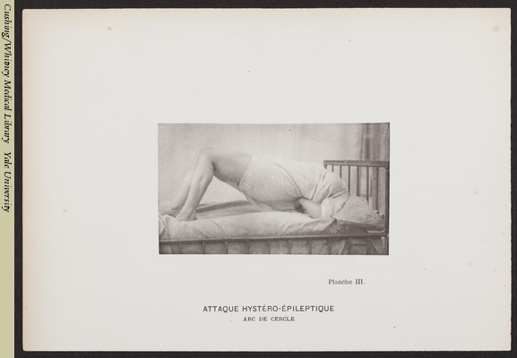

*Attaque Hystéro-Épileptique*, from *Iconographie photographique de la Salpêtrière (Vol. 3)*, 1880, images taken from the Cushing/Whitney Medical Library at Yale University

Fig. 2:

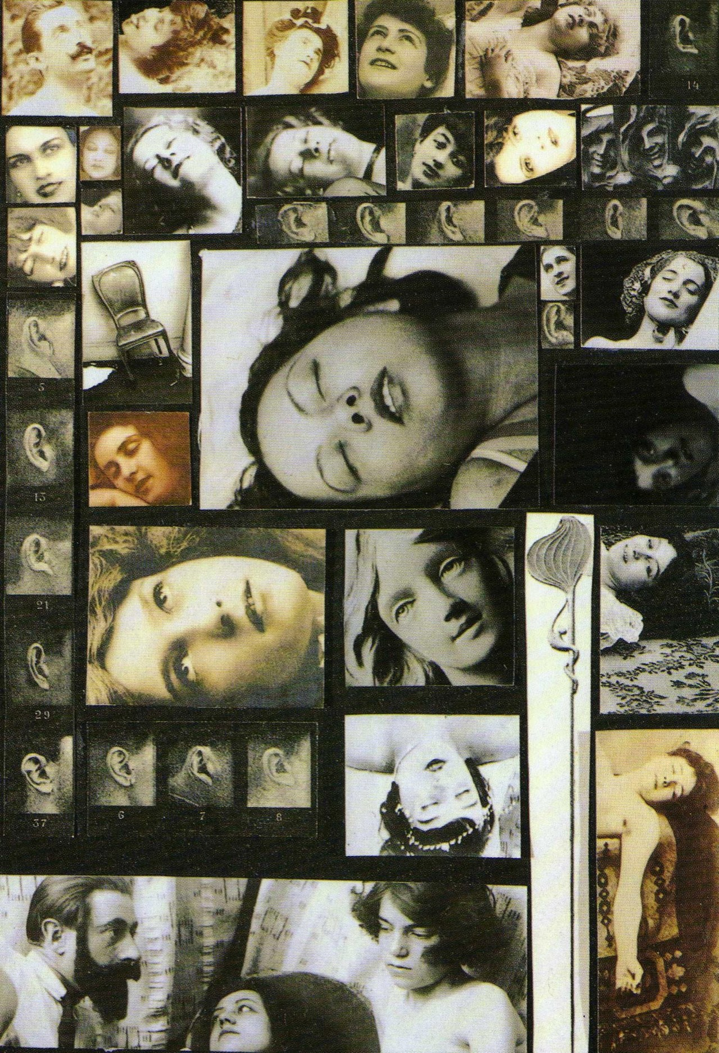

Salvador Dali, *The Phenomenon of Ecstasy*, 1933, photo-collage

Fig. 3:

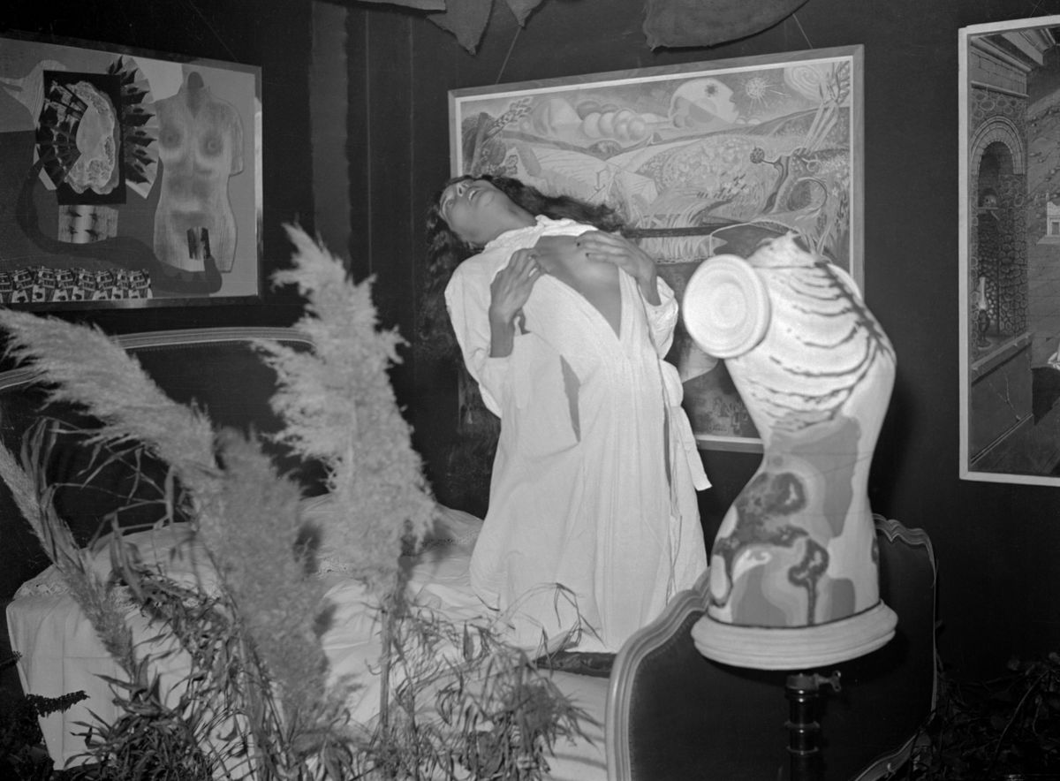

Hélène Vanel, *Unconsummated Act*, at the 1938 *Exposition Internationale du Surréalisme*

Fig. 4:

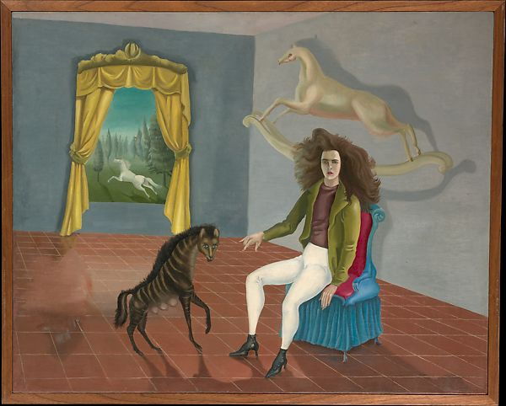

Leonora Carrington, *Self-Portrait (Inn of the Dawn Horse)*, 1938, oil on canvas, 65 x 81.3 cm.

Fig. 5:

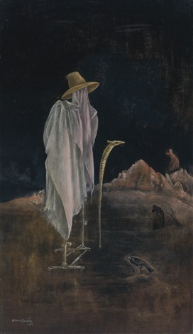

Leonora Carrington, *Self-Portrait with Orthopedic Brace*, 1973, oil on canvas, 66 x 38.1 cm.

Fig. 6:

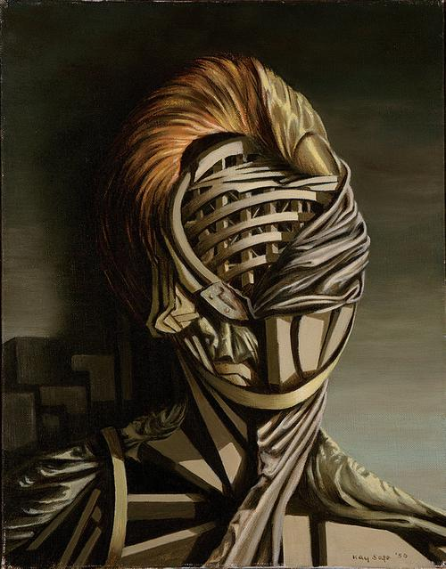

Kay Sage, *Small Portrait*, 1950, oil on canvas, 14 ½ x 11 ½ in.

Fig. 7:

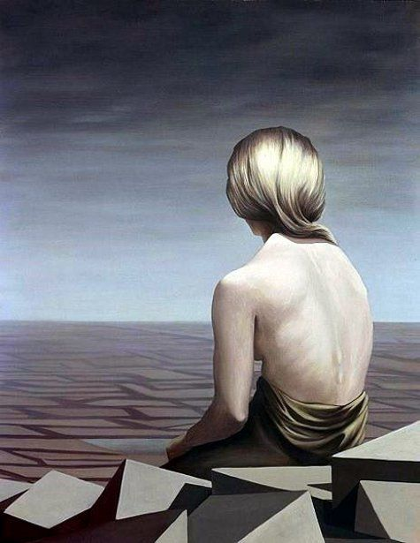

Kay Sage, *Le Passage*, 1956, oil on canvas, 91 x 71cm.

Fig. 8:

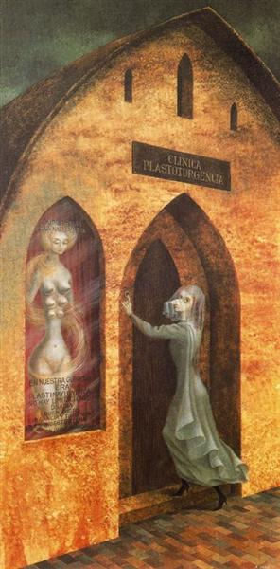

Remedios Varo, *Visit to the Plastic Surgeon*, 1960, oil on masonite, 71 × 35.5 cm.

Fig. 9:

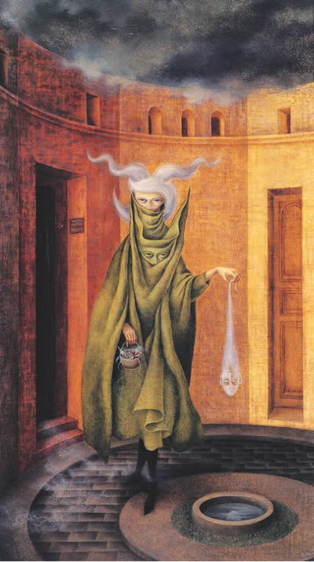

Remedios Varo, *Woman Leaving the Psychoanalyst’s Office*, 1960, oil on canvas, 71 x 41 cm.

1. André Breton, *Manifestoes of Surrealism* (Ann Arbor: University of Michigan Press), 1969, 26.
2. *Ibid.,* 28.
3. *Ibid.,* 28.
4. Charles Cramer and Kim Grant, “Surrealism and Women,” (Smarthistory), 2020, 1.
5. Barry Stephenson, “Charcot’s Theatre of Hysteria,” (Journal of Ritual Studies), 2001, 28.
6. *Ibid.,* 28.
7. Désiré Magloire Bourneville and Paul Regnard, *Iconographie photographique de la Salpêtrière*, (Aux Bureaux du Progrès Médical), 1880.
8. Jean-Michel Rabaté, "Loving Freud Madly: Surrealism between Hysterical and Paranoid Modernism," *(Journal of Modern Literature)*, 2002, 64.
9. Mary Ann Caws, Rudolf E. Kuenzli, and Gwen Raaberg, *Surrealism and Women*, (Cambridge, MA: MIT), 1995, 18.
10. Anna Souter, “The Dark Side of Surrealism That Exploited Women's ‘Hysteria,’” (Artsy), 2019.
11. “Surrealism and Women Artists,” (Los Angeles County Museum of Art), 2012, 1.
12. Naomi Blumberg, “Leonora Carrington,” (Encyclopædia Britannica), 2020.
13. Kristoffer Nohedan, "Leonora Carrington, Surrealism, and Initiation: Symbolic Death and Rebirth in Little Francis and Down Below," (*Correspondences* 2), 35.
14. Ann Hoff, "‘I Was Convulsed, Pitiably Hideous’: Convulsive Shock Treatment in Leonora Carrington's ‘Down Below’," (*Journal of Modern Literature),* 2009, 84.
15. *Ibid.,* 85.
16. Whitney Chadwick, "Leonora Carrington: Evolution of a Feminist Consciousness," (*Woman's Art Journal*), 1986, 38.
17. *Ibid.,* 38.
18. *Ibid.,* 38.
19. *Ibid.,* 38.
20. Hoff, "‘I Was Convulsed, Pitiably Hideous’...," 85.
21. Judith D. Suther, *A House of Her Own: Kay Sage, Solitary Surrealist*, (U of Nebraska Press), 1997, 1-2.
22. *Ibid.,* 4.
23. *Ibid.,* 13.
24. Salomon Grimberg, Review of: *A House of Her Own: Kay Sage, Solitary Surrealist,* (Woman's Art Journal*)*, 1999, 56.
25. *Ibid.,* 56.
26. Suther, *A House of Her Own: Kay Sage, Solitary Surrealist*, 15.
27. Renäe Riese Hubert, *Magnifying Mirrors: Women, Surrealism, & Partnership*, (U of Nebraska Press), 1994, 179.
28. Salomon Grimberg, Review of: *A House of Her Own: Kay Sage, Solitary Surrealist,* (Woman's Art Journal*)*, 1999, 57.
29. *Ibid.,* 57.
30. *Ibid.,* 57.
31. Janet A. Kaplan, "Remedios Varo: Voyages and Visions," (*Woman's Art Journal*), 1980, 1, 14.
32. Janet A. Kaplan, "Remedios Varo," (*Feminist Studies*), 1987, 38.
33. Kaplan, "Remedios Varo: Voyages and Visions," 14.
34. Jacquelyn Yvonne White, "The Surrealist Woman: the Art of Remedios Varo," (Syracuse University Honors Program Capstone Projects), 2014, 32.
35. *Ibid.,* 33.
36. Kaplan, "Remedios Varo: Voyages and Visions," 15.
37. *Ibid.,* 15.
38. Kaplan, "Remedios Varo," 44.
39. *Ibid.,* 44.